**EXPERIMENT 14: CREATE A SNAPSHOT OF A VM AND TEST IT BY LOADING THE PREVIOUS VERSION/CLONED VM**

**AIM:**

To create a snapshot of a vm and test it by loading the previous version/cloned vm

**PROCEDURE:**

**STEP 1:** GOTO VMWARE WORKSTATION**.**

**STEP 2**: CLICK ON VM AND SELECTS SNAPSHOT-> TAKE SNAPSHOT.

**STEP 3:** SNAPSHOT IS BEING DONE

**IMPLEMENTATION:**

**STEP 1: GOTO VMWARE WORKSTATION**

1.

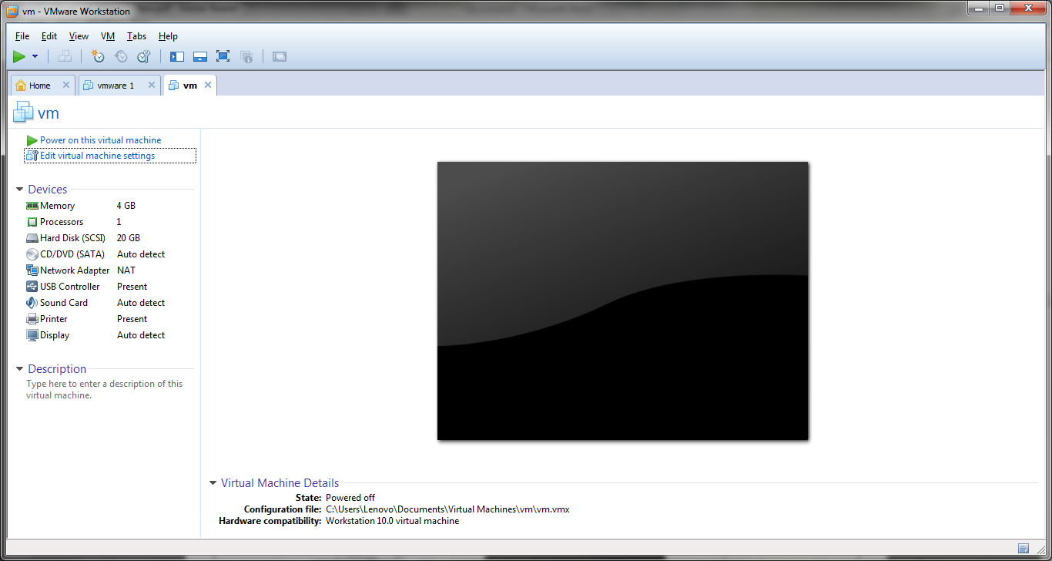

2.TAKE SNAPSHOT 1

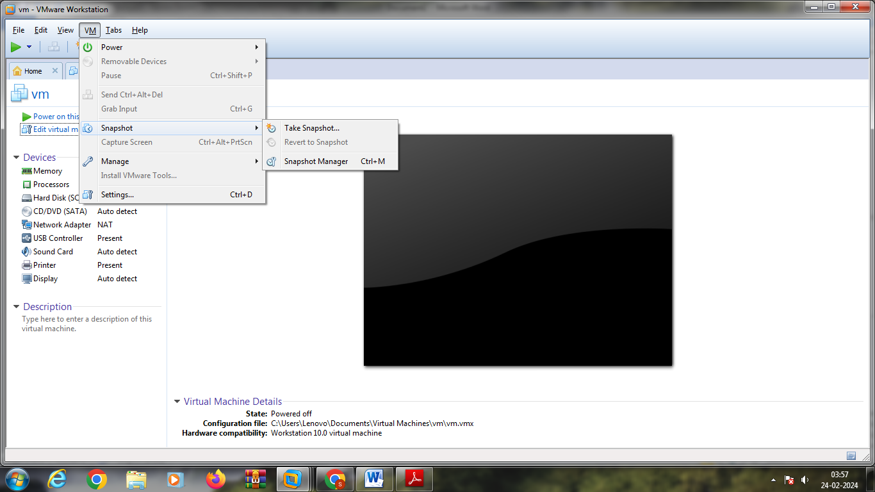

3.

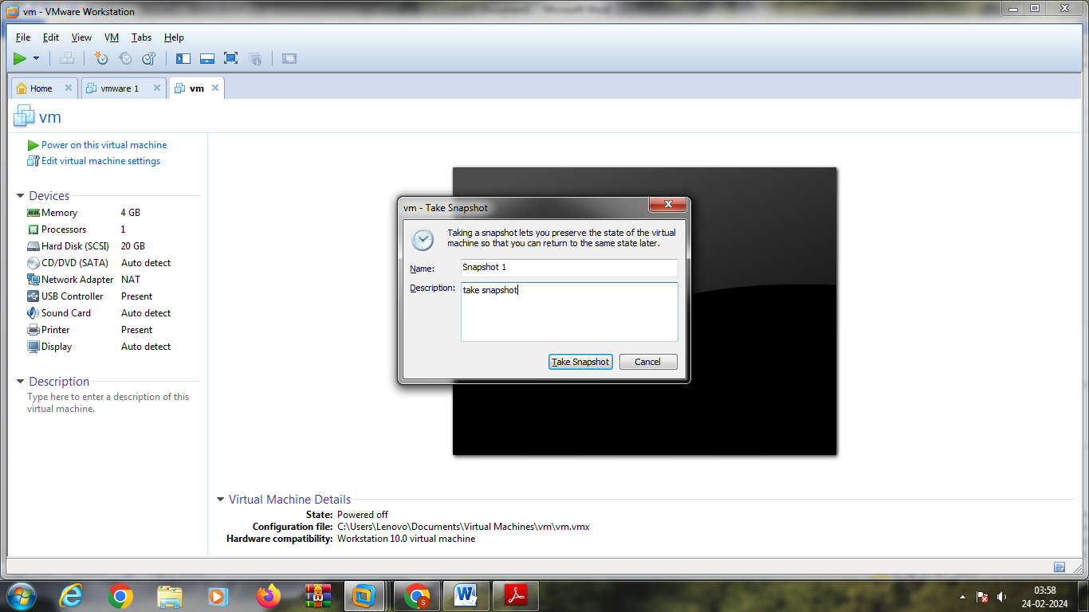

4.MODIFY CHANGE IN MEMORY SIZE TO 2 GB

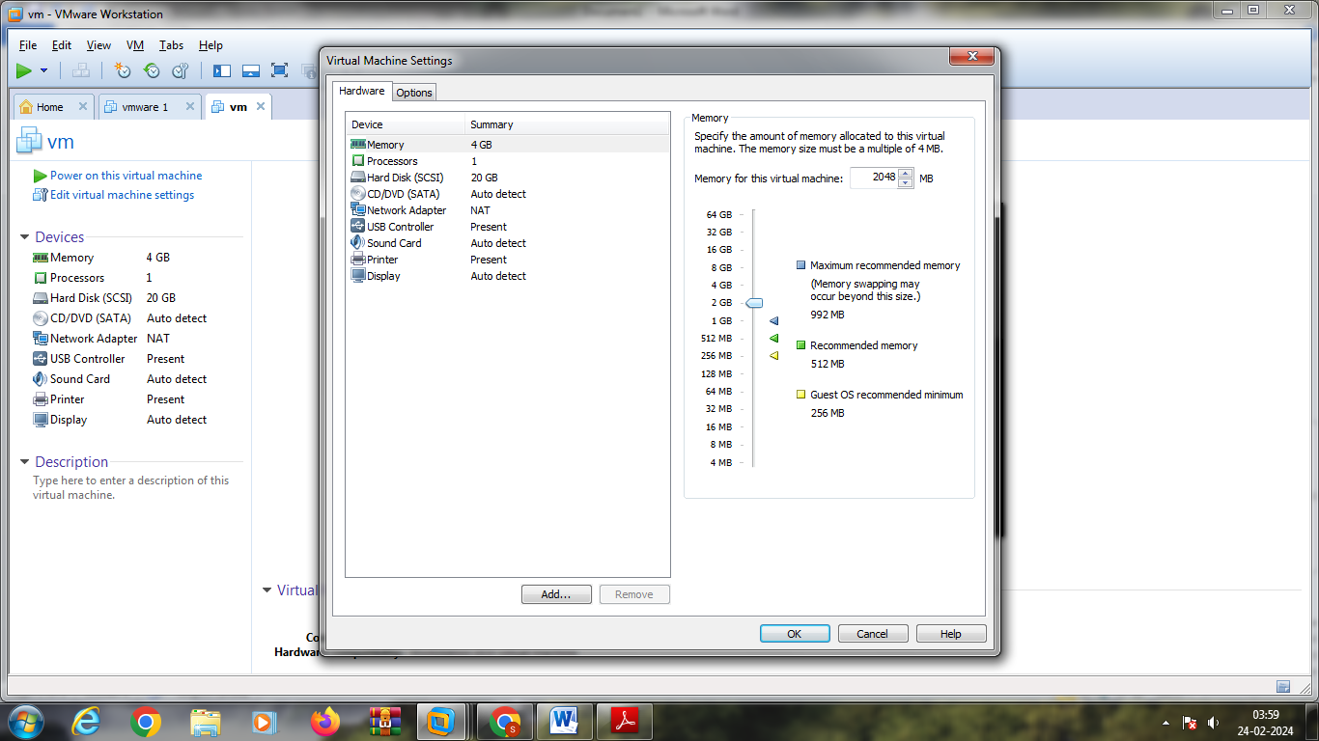

5.TAKE SNAPSHOT

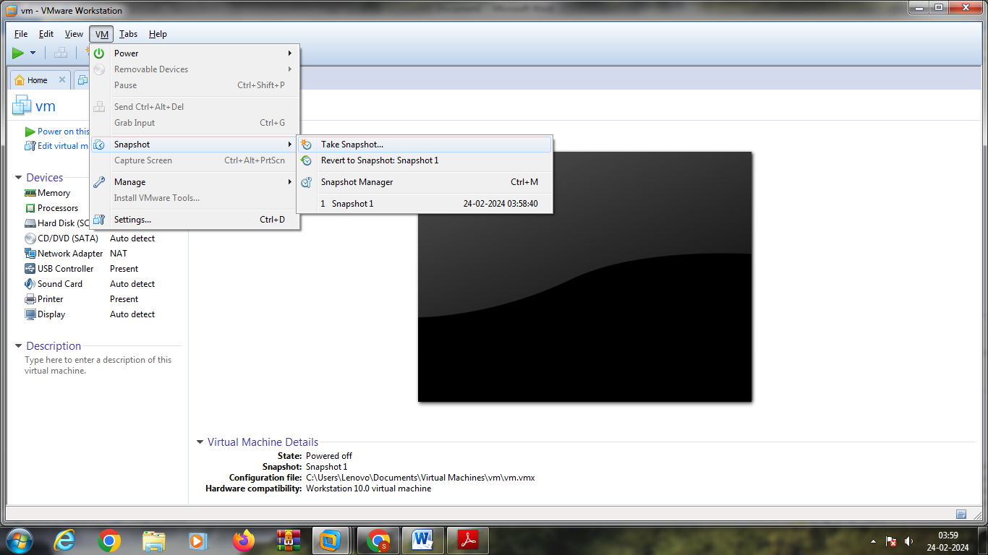

6.SNAPSHOT 2

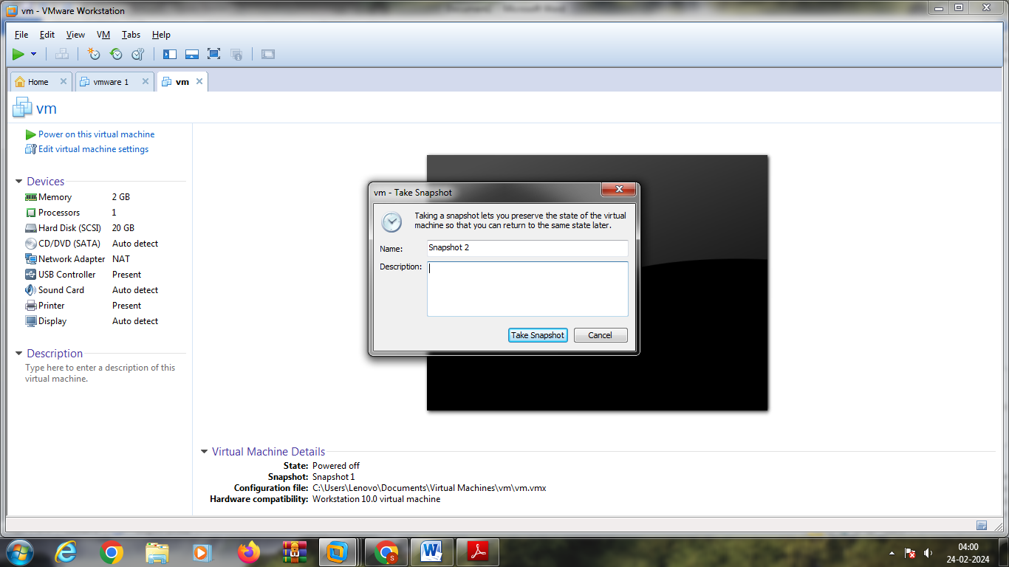

7.CREATE NEW HARDDISK

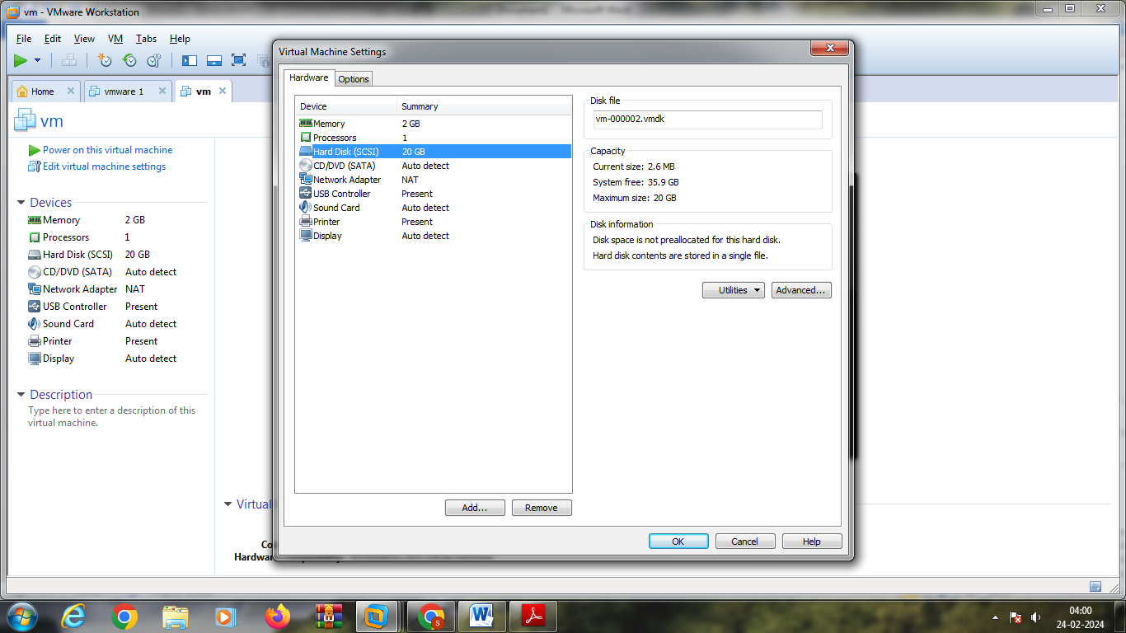

8.

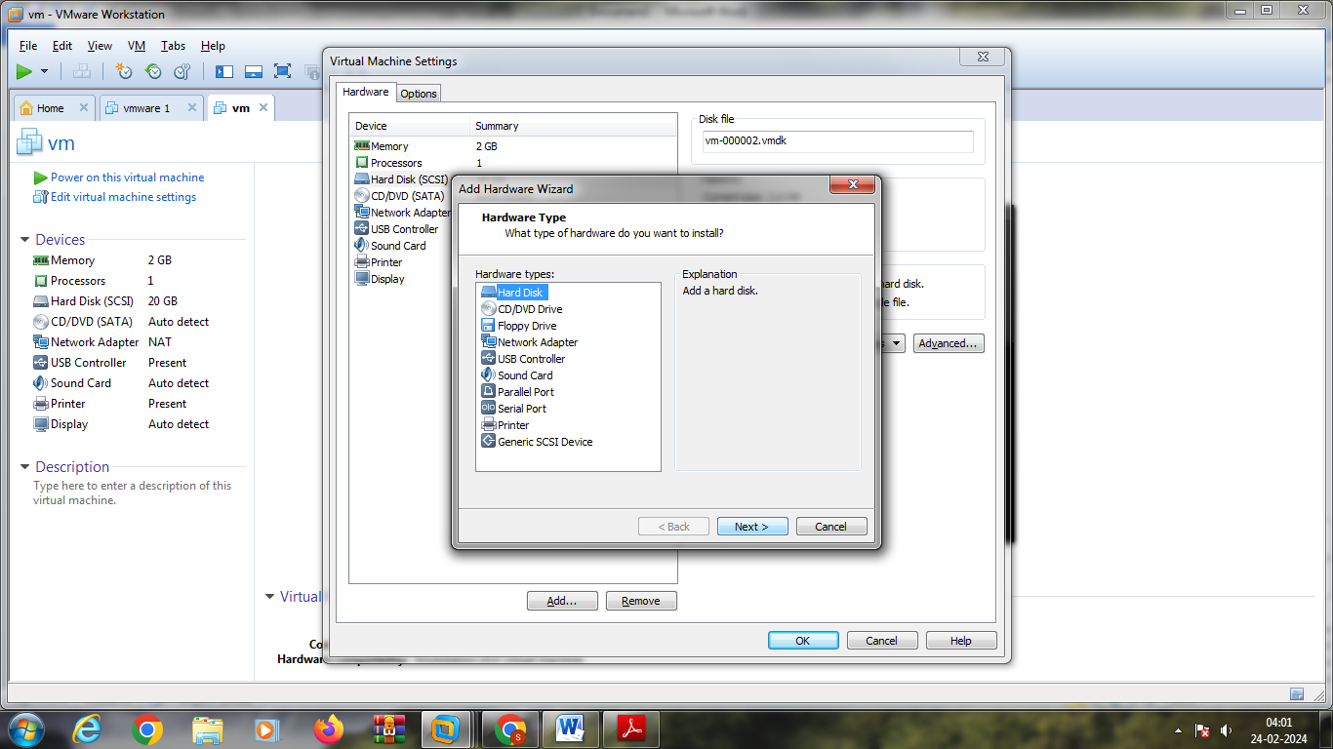

9.

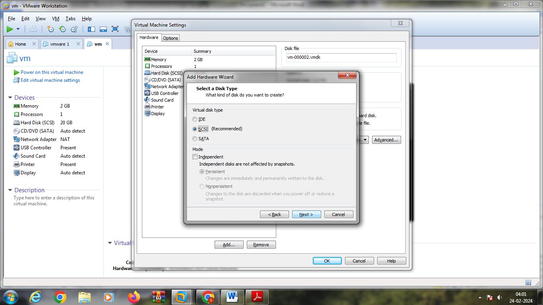

10.

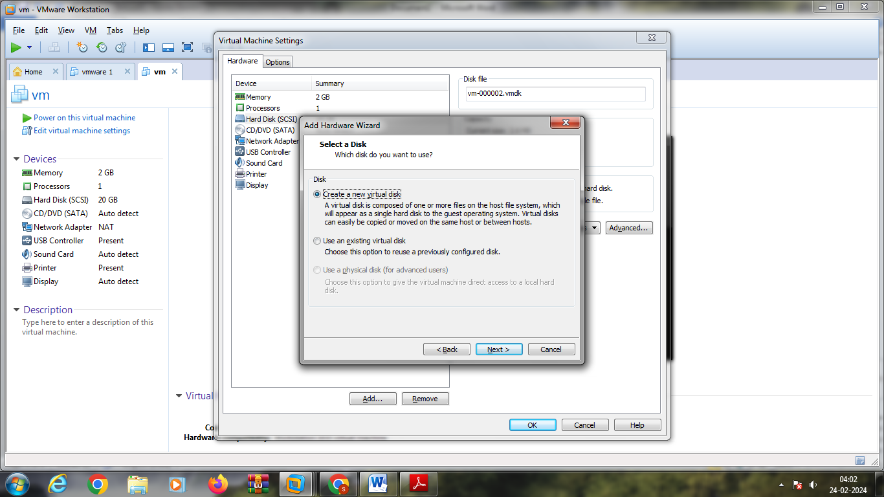

11.

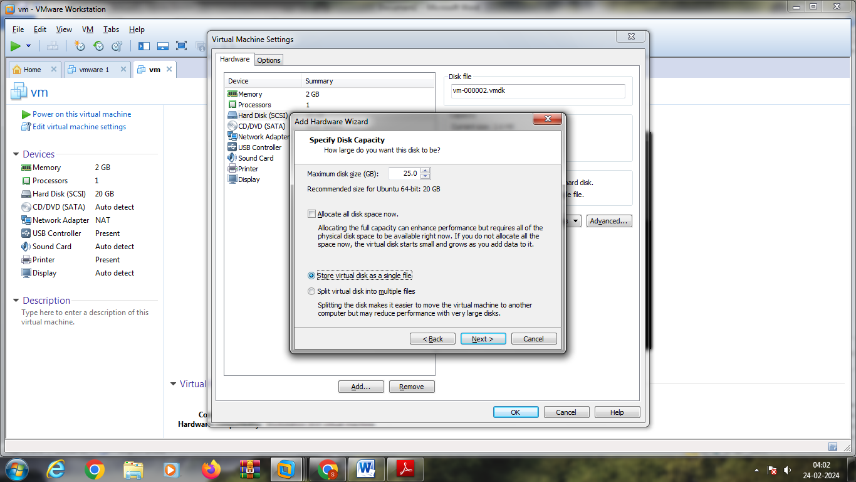

12.MODIFIED CHANGE BY ADDING ANOTHER HARDDISK

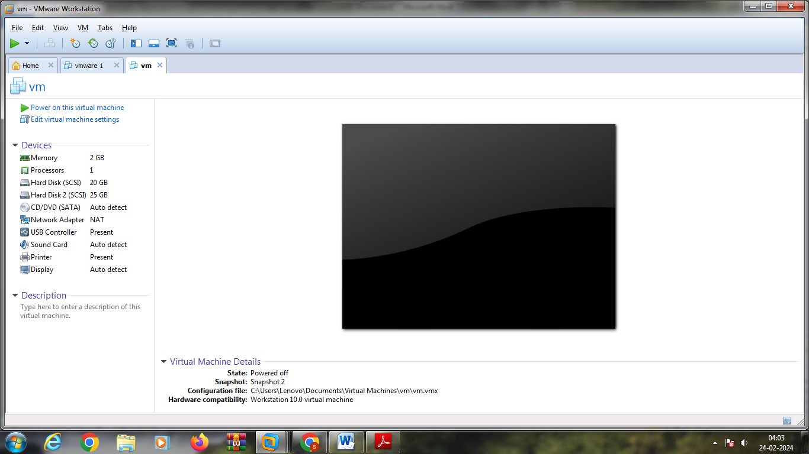

13.TAKE SNAPSHOT 3

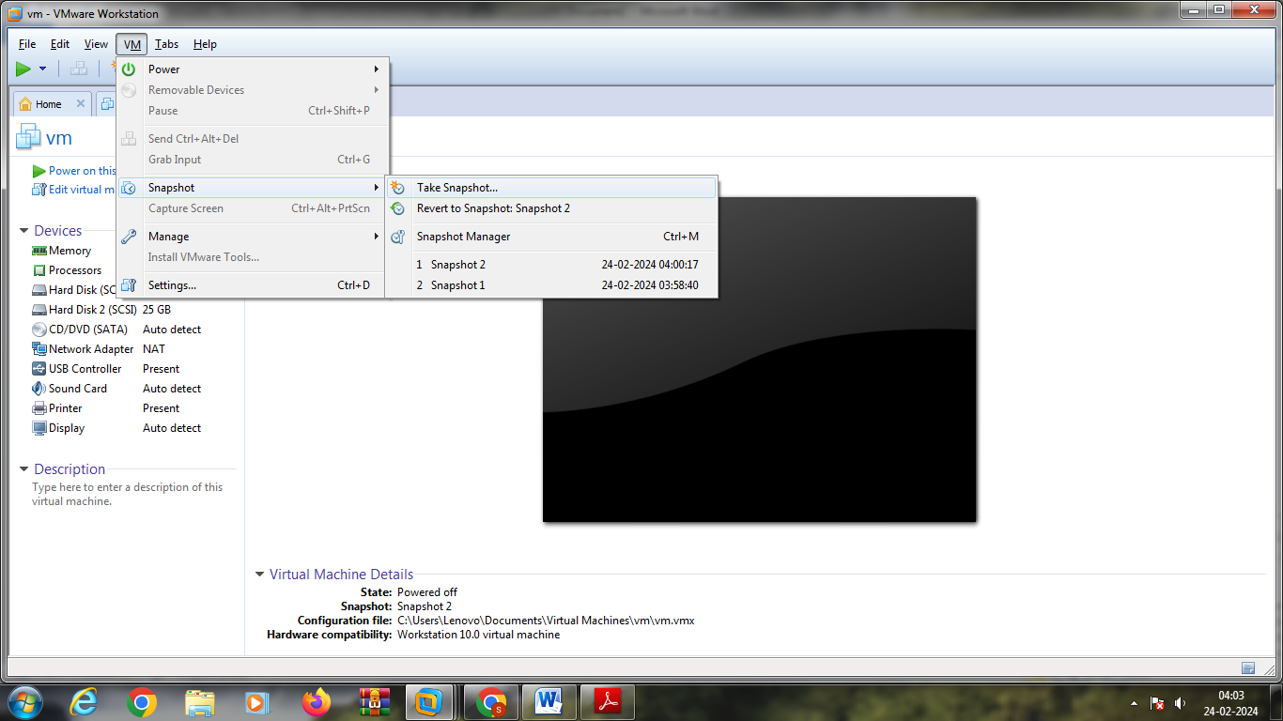

14.CLICK SNAPSHOT MANAGER

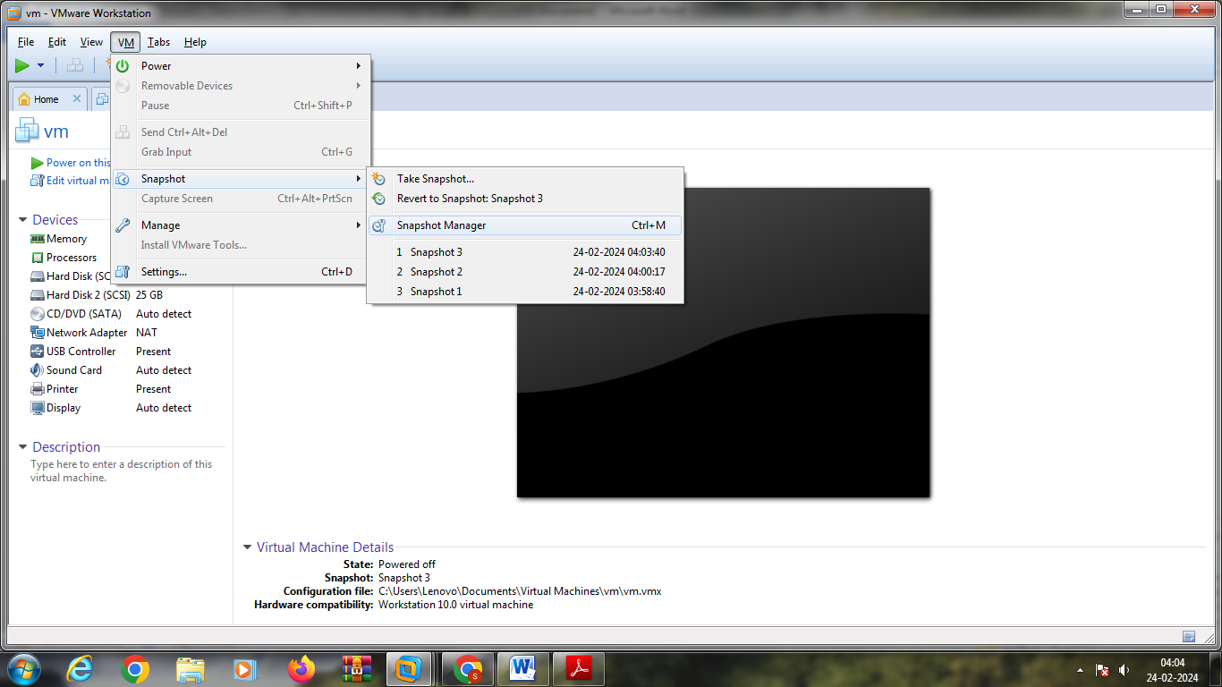

15.

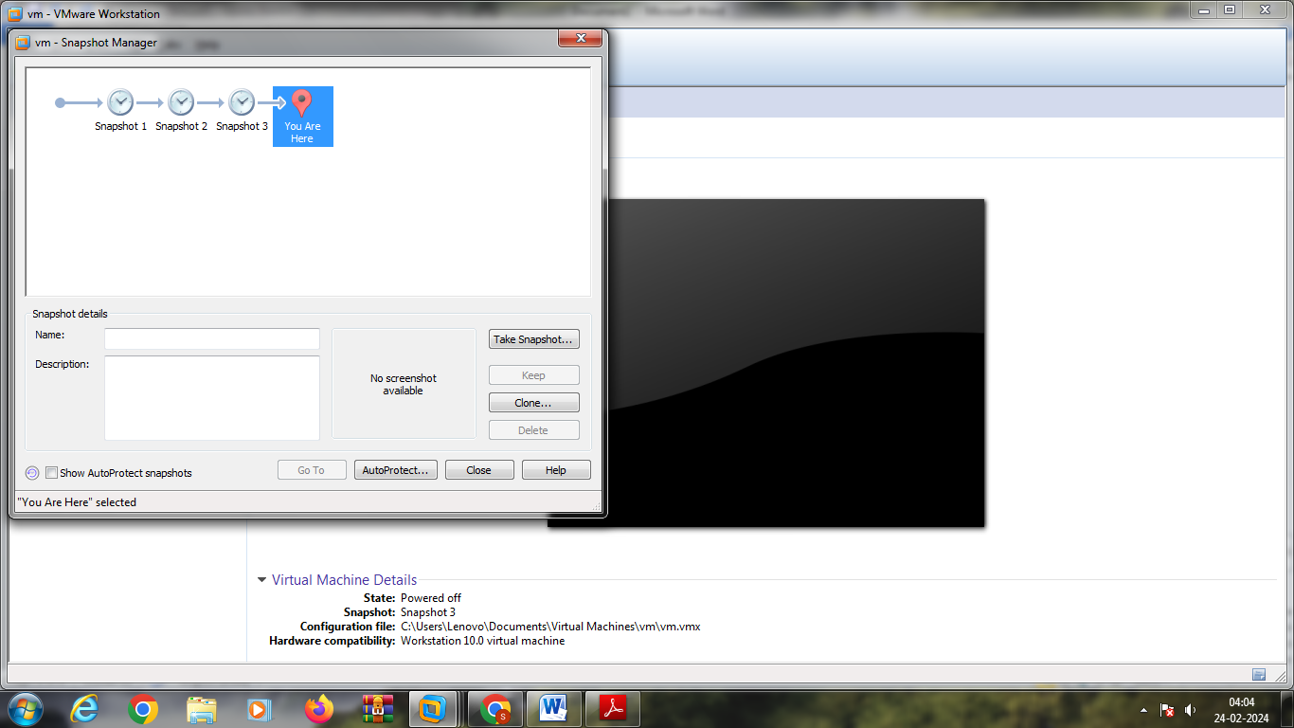

`16.SELECT ANY SNAPSHOT

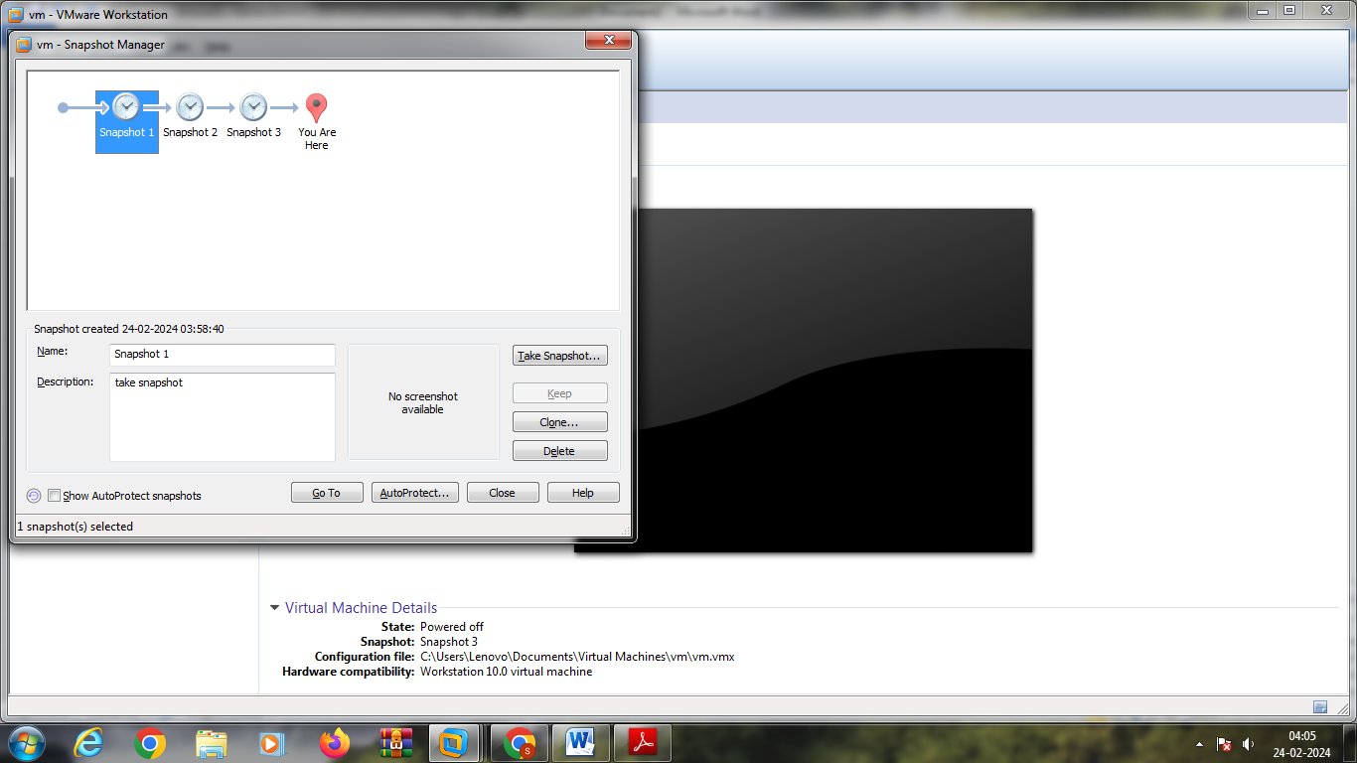

17.

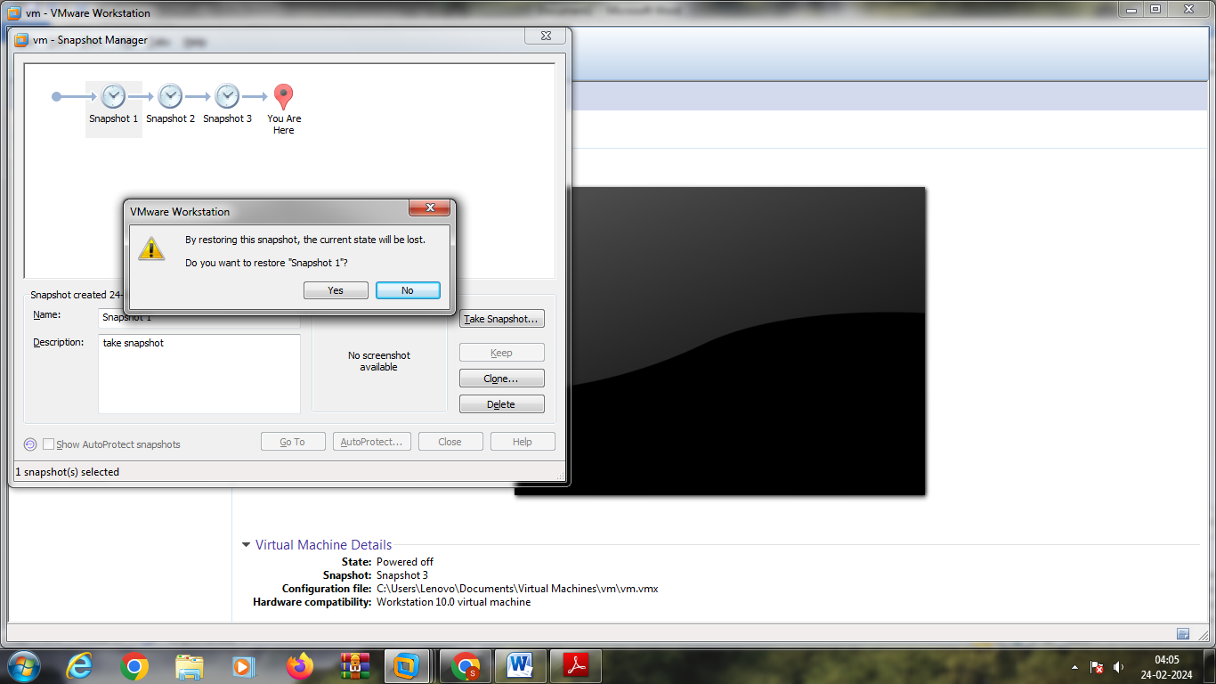

18. SNAPSHOT IS DONE

